**PROJECT REPORT**

**“HIRE-HORIZON”**

By

ASHWIN YADAV

ENROLLOMENT NO: - 202326900131

Under the Supervision of

Honey Patel

A Report Submitted to

Gujarat University

In Partial Fulfilment of the Requirements for the Degree of B.Sc. IT in

DATA MANAGEMENT & VISUAL INSIGHT

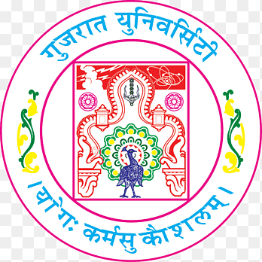

Center for Professional Courses Gujarat University,

Navrangpura, Ahmedabad - 380009, Gujarat

* **CERTIFICATE**

This is to certify that research work embodied in this report entitled **“HIRE-HORIZON”** was carried out by **YADAV ASHWIN** (**202326900131**) at Centre for Professional Course for partial fulfilment of B.Sc. IT degree to be awarded by Gujarat University. This research work has been carried out under my supervision and is to the satisfaction of department.

Date:

Place:

Guide Name Coordinator Name

Honey Patel SAURABH DAS

CPC, Gujarat University CPC, Gujarat University

Director Name

**Dr. Paavan Pandit**

CPC, Gujarat University

Seal of Institute